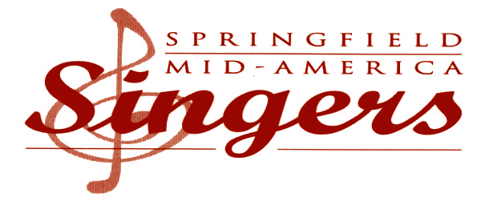

August 15, 2016

**Tom Matrone**

*Artistic Director*

**Board of Directors**

**Jennifer Robinett**

*President*

**Peggy Gawley**

*Vice President*

**Mary Belle Graham**

*Secretary*

**David Siewert**

*Treasurer*

**Maureen Bohannan**

**Mark Bowdidge**

**Brad Cowles**

**Molly Faulkner**

**Denise McIntosh**

**Janet Morris**

**Dan Serven**

«Program_Name»

«Address»

«City_State»  «Zip»

Dear Saluatation,

At such a time as this, music is essential to our community experience.  Nothing soothes the soul or inspires the heart quite like our voices singing as one.

The Springfield Mid-America Singers are in the midst of our 49th year of music-making under the artistic direction of Tom Matrone. Called together by our love of singing, the Springfield Mid-America Singers are devoted to enriching the community through excellence in choral music.

In 2011, we made all our concerts free to the public in celebration of our 45th anniversary. We’d like to continue this gift and we need YOUR help to match support from Family Pharmacy as our official community partner. Unfortunately, due to the ecomony and state legislative priorities, we need to make up a $5,000 gap in funding from our annual Missouri Arts Council grant. **Would you consider joining us this season at the “Sustainer” level to help make up the difference?**

Enclosed is our 2012-2013 Concert Season Brochure describing the SUSTAINER role. For your convenience, also enclosed is a self-addressed, stamped envelope.

Your generosity makes the gift of music possible.  Thank you for your consideration!

Jennifer Robinett Sig001.tif

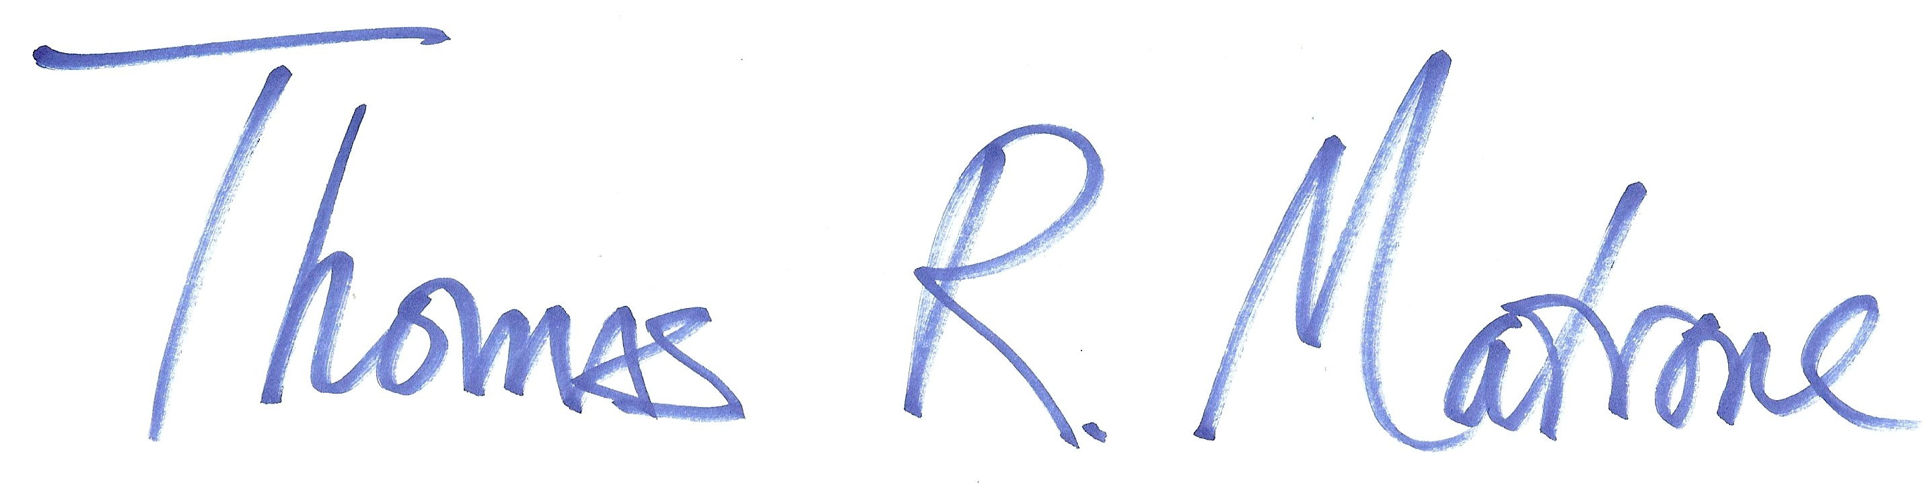

Yours for the Music,

Jennifer Robinett Tom Matrone

*President, Board of Directors Artistic Director*